Database Assignment

Vijayasimhan Ganesan

Exercise-1

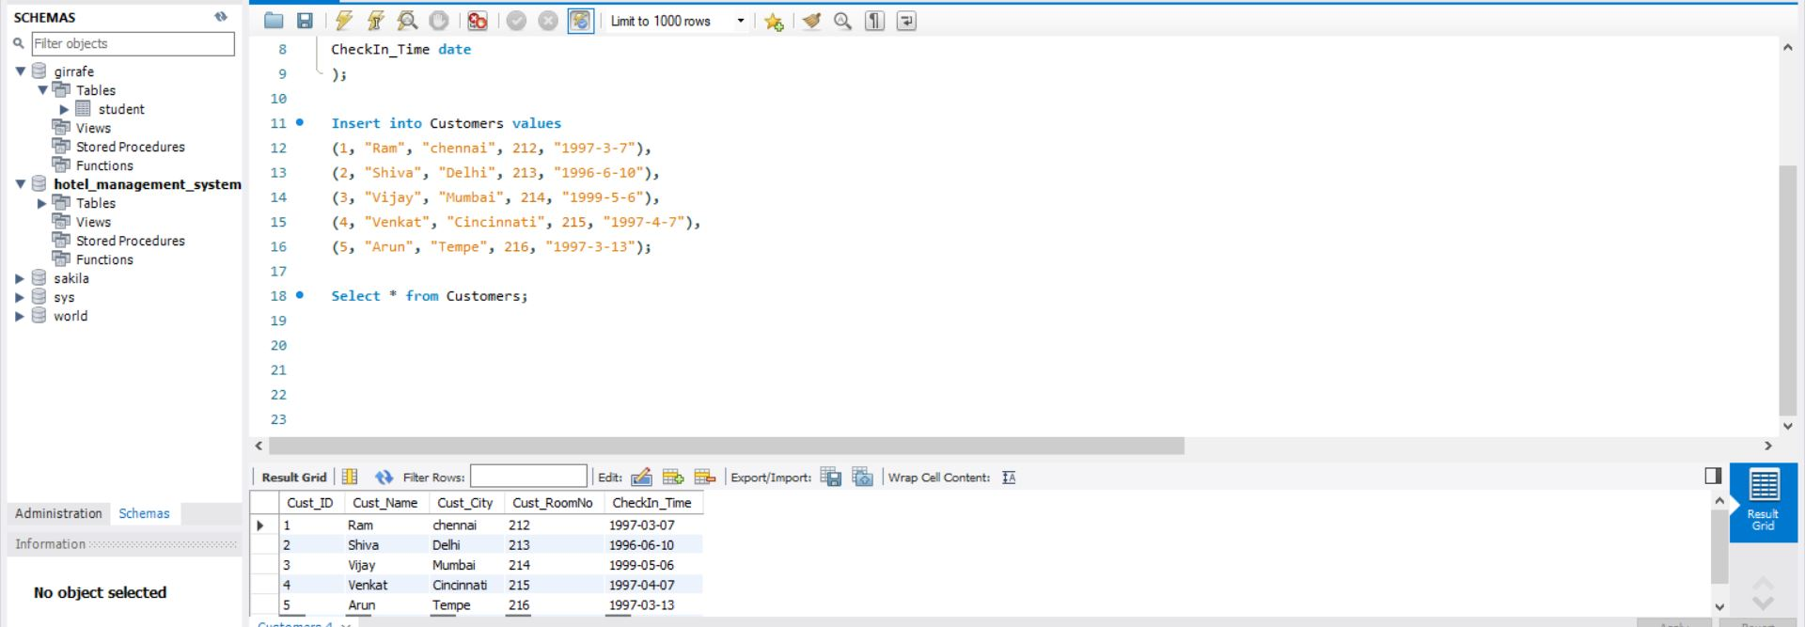

Exercise-2

Print Distinct City from Table Customers and Print Count Distinct City from Table Customers.

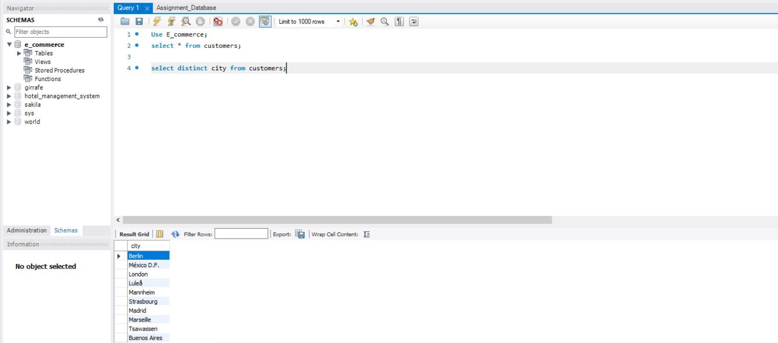

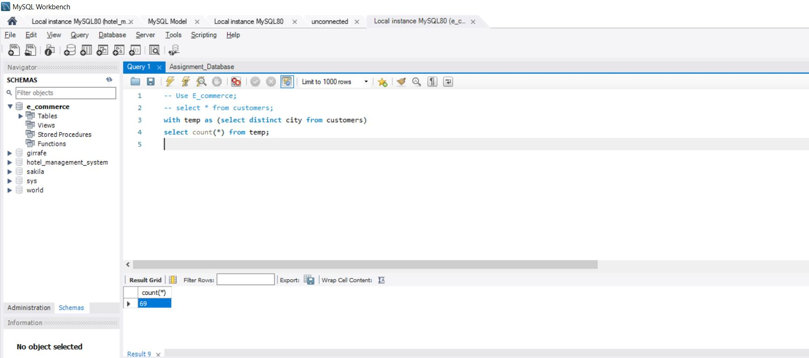

Write a SQL query to get the least number of quantities and the highest number of quantities bought by the user consider the OrderDetails Table.

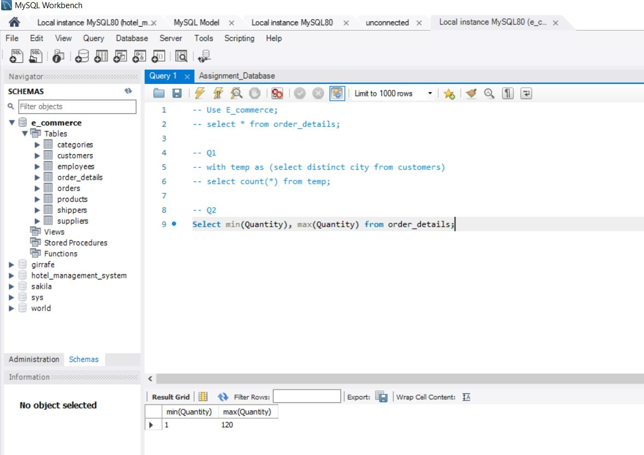

Print the total and an average number of quantities ordered by users, consider the OrderDetails Table.

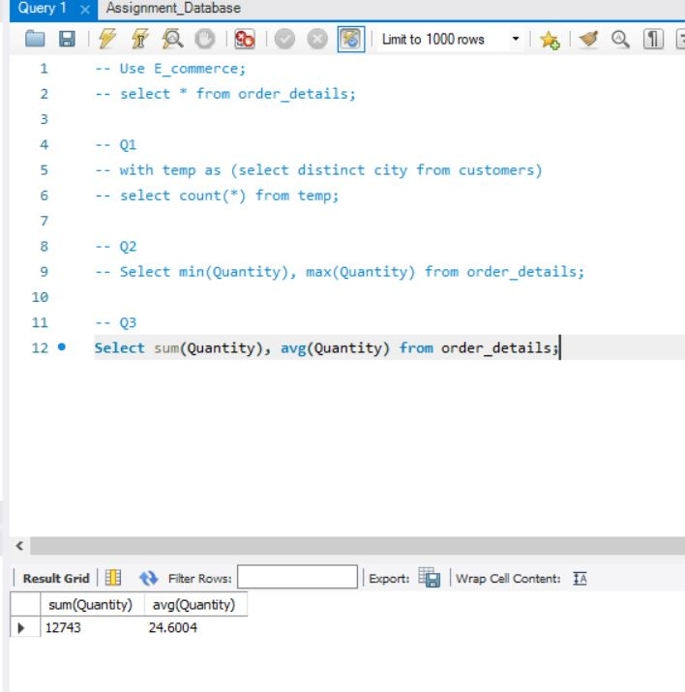

Print name of the product which is present at the 5th position till the 15th position from Products table, use LIMIT keyword.

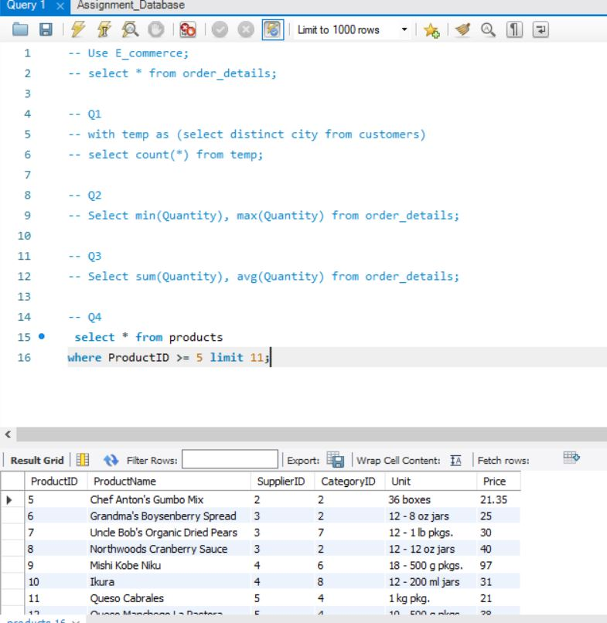

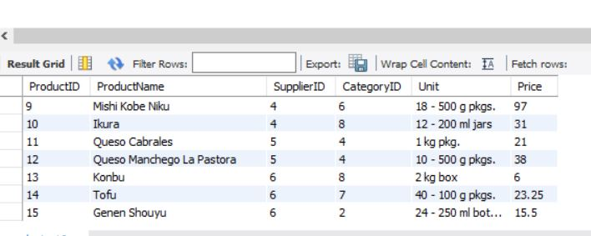

Write a SQL query for all the details of the supplier whose name consists of “A” at the second position from the Suppliers table.

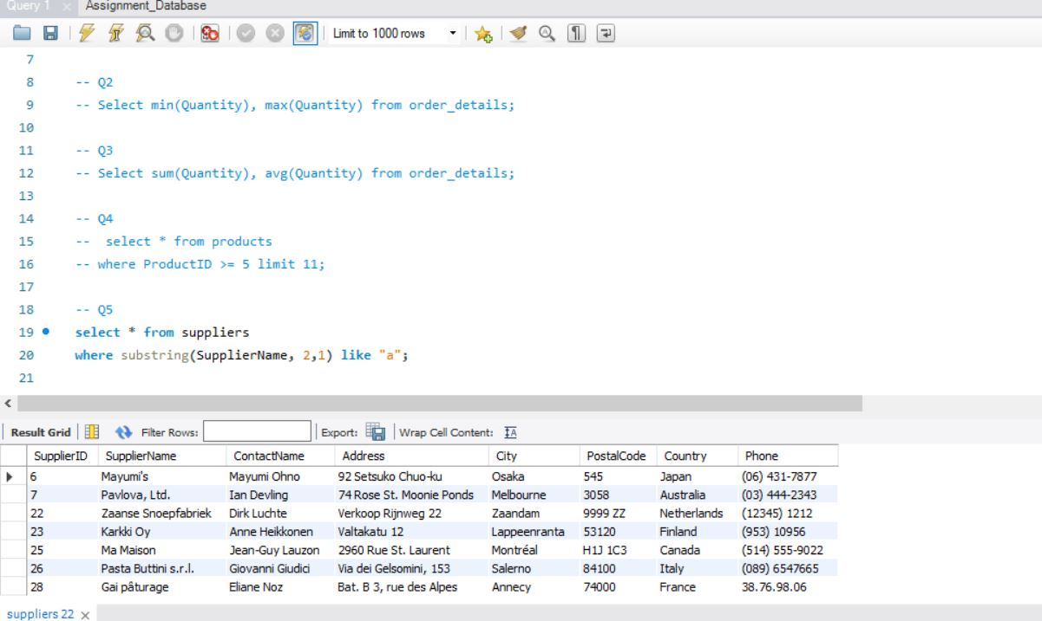

Print the details of the customer who doesn’t stay in the USA and Canada from the Customers table.

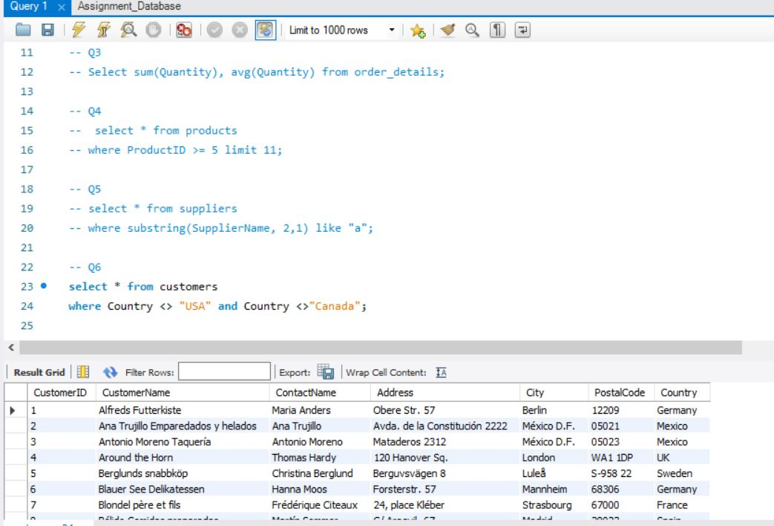

Write a query to show the distinct city and their count from the Customers table.

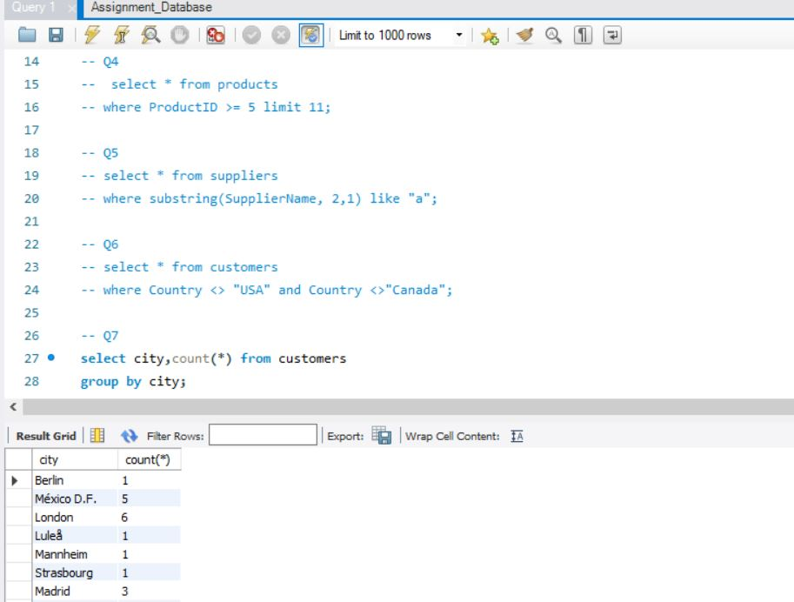

Write a query to fetch details of all employees excluding the employees with last names, “Sanjay” and “Sonia” from the Employees table.

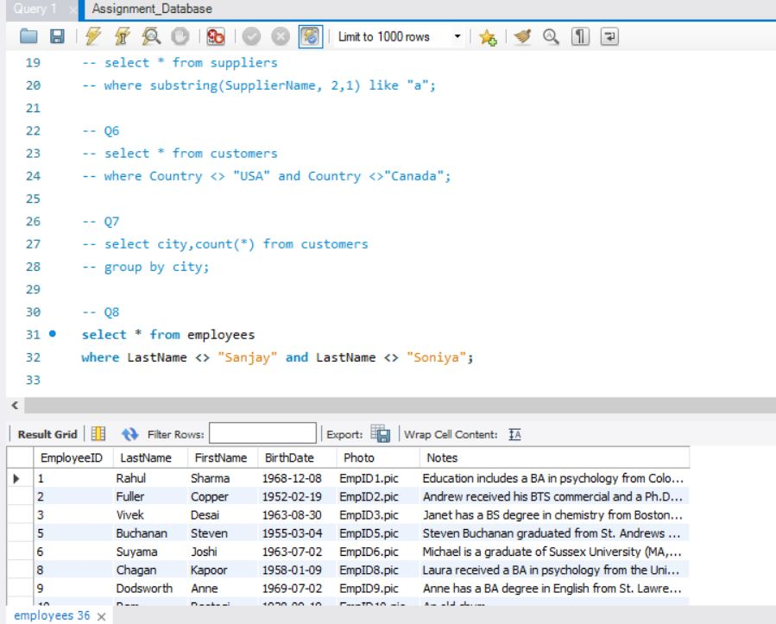

Duplicate a table as similar to the Suppliers table and name it as SupplierDetail.

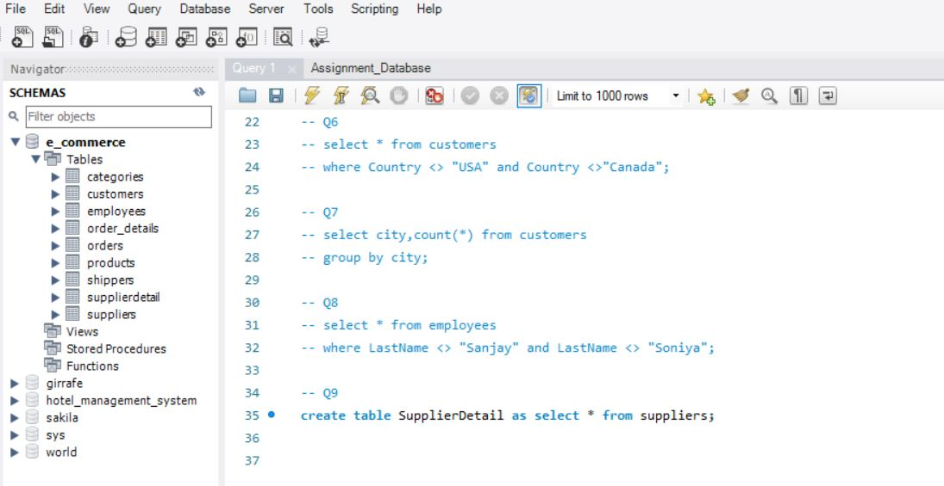

Delete customer details whose country is Venezuela and print the rest of the Customer table

